**Preparation and characterization of TiO2 pillared clay: effect of palladium and photosensitizer on**

**photocatalytic activity**

**Bachir D. Hadj1,2, Khalaf H.2*, Ferroukhi S.2, Boutoumi Y.2, Schnee J.3 and Gaigneaux E.M.3**

1. Veterinary Institute, University of Blida 1, BP 270, Street of Soumaa, 09000 Blida, ALGERIA

2. Laboratory of Chemical Engineering (LCE), Department of Industrial Chemistry, Faculty of Engineering Sciences (FES),

University of Saad Dahlab of Blida, Box 270, 09000 Blida, ALGERIA

3. Université catholique de Louvain, Institute of Condensed Matter and Nanosciences (IMCN), Place Louis Pasteur 1. L04.01.09,

1348 Louvain-la-Neuve, BELGIUM

*[eric.gaigneaux@uclouvain.be](mailto:eric.gaigneaux@uclouvain.be)

***Abstract***

*A series of titania pillared Algerian montmorillonite was prepared from Na-montmorillonite using titanium isopropoxide and hydrochloric acid. Next to a reference clay pillared with TiO2 only(Mont-TiO2), a clay pillared with the palladium doped TiO2 was also synthesized(Mont-(TiO2-Pd)) as well as a TiO2-pillared clay photosensitized by the introduction of the methylene blue dye into the suspension of the TiO2-pillared clay(Mont-TiO2)-BM.*

*The prepared materials were characterized by X-ray diffraction (XRD), micro X-ray fluorescence (µFX), Scanning electron microscopy (SEM), Differential and thermo-gravimetric analysis (DTA/TGA), Fourier transformed infrared (FT-IR), specific area and porosity determinations. The prepared materials are porous and exhibit a good thermal stability as indicated by their surface areas after calcination by microwave. Their photocatalytic performance was evaluated in the photodegradation of phenyl urea herbicide (precisely, Linuron). The TiO2 pillared clay (Mont-TiO2) is shown to be the best photocatalyst in term of photocatalytic activity.*

**Keyword:** TiO2-pillared clay, montmorillonite, heterogeneous photocatalysis, phenylurea pesticides, Linuron.

**Introduction**

Clay minerals are a class of inorganic layered silicate materials which have attracted significant attention due to their high abundance and low cost. They are chemically inert and resistant to deterioration**.** Their special properties ranging from sorptive, swelling, ion exchange, acidic and textural properties make clays attractive for various applications like adsorption and catalysis; they can also be used to remove organic pollutants from wastewaters1-7.

The level of interest for clays among the scientific community has increased dramatically in recent years due to their intercalation chemistry and various modification possibilities*.* Pillared smectites are clays of high permanent porosity obtained by separating the clay sheets by a pillaring agent. These pillaring agents can be organic, organometallic, or inorganic complexes, preferably of a high positive charge5,8-16.

Since the first work introducing the aluminum intercalated clay family in the early 1970s, interest in the synthesis of pillared interlayer clays has increased tremendously, especially research into the properties and applications of new synthesis methods17.

Now, the inorganic polyoxocations are of great interest because the corresponding inorganic pillared clays such as the common Al-pillared clay, Fe-pillared clay, Zr-pillared clay, Cr-pillared clay and Ti-pillared clay, have high specific surface area and better thermal stability; thus, their pores remain stable in high temperature reactions18-27. Among them, poly(hydroxo)titanium pillars were intensively studied because Ti-pillared clay have the following characteristics: (1) a large specific surface area and uniform pore size, (2) interlayer titanium dioxide primarily in the form of pillars bonded to the tetrahedral sheets in the clay and (3) a strong solid acidity. There are potential broad applications of Ti-pillared clay as solid catalysts and adsorbent in the petrochemical industry, fine chemicals industry and environmental protection field. They can also be used as photocatalysts for effective treatment of wastewaters polluted with toxic organic compounds28-31.

Heterogeneous photocatalysis based on semiconductors like TiO2, ZnO, Fe2O3, CdS, ZnS, Nb2O5, Ta2O5 and BiTaO4 is extensively investigated in view of its applications in the detoxification of polluted water**.** Nevertheless, TiO2 has been the most studied semiconductor photocatalyst due to its high activity under UV irradiation, high stability against photocorrosion process, chemical inertness, non-toxicity and low cost32-37.

However, ultra-fine powders have a strong tendency to agglomerate into larger particles, resulting in an adverse effect on catalyst performance. In some cases, agglomerates could block the penetration of light into the solution. It might also be very hard to recover the powders after the reaction, leading to a potential difficulty in downstream separation38. To overcome these limitations and have superior activity performance of photocatalysts, various kinds of supports are most widely used to immobilize the active phases. Among them clays such as montmorillonite have attracted much attention in recent years.The intercalation of TiO2 into the interlayer of montmorillonite is one of the effective methods to induce the photocatalytic decomposition of the organic pollutants20,21,23-41.

In general, TiO2-pillared clays are prepared through a cation exchange approach between the interlayer sodium ions and positively charged sol particles of titanium hydrate, [TiO(OH)x]mn+ with size ≤ 2 nm.

Here we used an organic-dye (methylene blue) to boost the performance of our pillared clay in the process of the photodegradation of Linuron. Doping TiO2-pillared clay with a transition metal, precisely palladium, has also been extended here in order to improve the performance, in particular by narrowing the energy band gap in the electronic structure of titanium. This approach can indeed lead to produce materials with better photocatalytic activity than the classical TiO2-pillared clay42-43. Our materials were thus prepared by introducing the palladium into the TiO2 sol before pillaring the clay. In this study, we describe the synthesis and characterization of TiO2 pillared clay with ratio of TiO2/HCl equal to 4 using the Stert method44. The prepared materials were characterized by different spectroscopic and thermal techniques and tested to evaluate their potential for removal of phenylurea herbicide (Linuron) from aqueous solutions, by adsorption and photodegradation.

**Material and Methods**

**Material and reagents:** The starting clay was a bentonite obtained from the Roussel deposit of Maghnia (Algeria). It is reported to be composed essentially of montmorillonite with minor impurities (quartz, feldspar, calcite, etc.). The structural formula is Na0.35K0.01Ca0.02(Si3.89Al0.11) (Al1.60Mg0.32Fe0.08)O10(OH)2.

The cation exchange capacity (CEC) of the montmorillonite is 90 meq per 100g of bentonite. Its chemical composition (wt%) is: SiO2 69.4; Al2O314.7;Fe2O3 1.2; MgO 1.1; CaO 0.3; Na2O 0.5; K2O 0.8; TiO2 0.2 and its mass loss by ignition at 1173 K is 11%.

This bentonite was purified using a sedimentation process to obtain a purified bentonite with a high montmorillonite content. The pure bentonite was then modified through cation exchange with a NaCl(1M) aqueous solution to obtain Na-Mont5. HCl, PdCl2, Methylene blue (C16H18ClN3S) were purchased from Fluka and Titanium (IV) isopropoxide [Ti(OC3H7)4] (100%) from Prolabo.

The pollutant used in this study is a phenylurea herbicide (Linuron) with chemical structure (C9H10Cl2O2N2): 3-(3,4-dichlorophenyl)-1-methoxy-methylurea. It was used without further purification. All aqueous solutions were prepared with deionized water.

The physicochemical properties and chemical structure of the Linuron are shown in table 1 and figure 1.

**Table 1**

**Physico-chemical properties of Linuron**

|  |  |  |  |
| --- | --- | --- | --- |
| **Compound** | **Molecular weight (g/mol)** | **Solubility in water (mg/l)** | **Vapor pressure**  **(Pa)** |
| Linuron | 249.1 | 52.7 at pH=5  63.8 at pH = 7 | 5.1 .10-3  at 20°C |

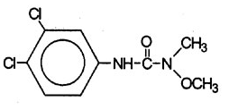

**Figure 1: Chemical structure of Linuron**

**Synthesis of pillared, Palladium doped and photosensitized TiO2-montmorillonite:**

* The pillaring agent was prepared using the sol-gel method by adding dropwise the titanium tetraisopropoxide into 1M HCl aqueous solution under continuous stirring for three hours at 50 °C until a clear solution was obtained. The molar ratio of HCl/Ti was equal to 4 and a titanium amount of 10mmol/g of montmorillonite was targeted according to the conditions reported in the literature44. The sol of titanium hydrate obtained was added drop by drop into a suspension of montmorillonite in water (1% wt) followed by stirring for 17h and then a sequence of washing with distilled water, centrifugation and drying at 40°C for 72h. Finally, the modified clay was calcined during 15min in a microwave apparatus at 800W. The photocatalyst obtained was named Mont-TiO25,45.
* The palladium doped TiO2 pillared clay was synthesized by adding 0.5% (w/w) of PdCl2 to a titanium hydrate sol prepared as described beforehand. This mixture was stirred for 4h in the dark. The product thus obtained was then added dropwise to a suspension of sodium montmorillonite (Mont-Na) and left under vigorous stirring for 48h. The suspension was then centrifuged and washed several times with distilled water, dried and then calcined in the microwave at an average power of 800W for 15min.The obtained material was named Mont-(TiO2-Pd)46.
* The methylene blue photosensitized TiO2 pillared clay was prepared by dissolving a quantity of methylene blue (10-3M) in a mixture of 2ml of methanol and 100 ml of 5% formic acid. To this solution was added 1g of Mont-TiO2, the suspension obtained is stirred for 24h away from light, before being centrifuged and washed several times and dried at a temperature of 80°C47. The sample was named (Mont-TiO2)-BM.

The different routes followed to prepare the catalysts are represented in the figure 2.

**Figure 2: Diagram of the preparation of photocatalysts**

**Characterization methods**

* X-ray diffraction (XRD) patterns of the resulting materials were performed on a PANalytical XPERT-PRO diffractometer using CuKα source operated at 45kV and 40mA. The samples were measured at room temperature in the range from 2ϴ = 2° to 70°. The scanning rate was 2°degrees per minute.
* Fourier transformed infrared (FT-IR) spectra were recorded in the range of 4000 to 400 cm-1 on a FT-IRBRUKER, type TENSOR 27 spectrophotometer. The acquisition consisted in accumulating 64 scans with a spectral resolution of 4 cm-1.
* Scanning electron microscopy (SEM) PHILIPS ESEM XL 30 with a tungsten filament was used to examine the morphology of the investigated samples using conductive carbon paint.
* Elemental analysis of the samples was conducted by micro X-ray fluorescence (µXF) on a HORIBA XGT-5000 spectrophotometer. The fluorescence spectra were recorded in the region extending from 0 to 40 keV.
* Nitrogen adsorption-desorption isotherms of the prepared materials were obtained at 77K by Micromeritics Tristar 3000 after proper degassing. BET surface area and total pore volume were calculated from the adsorption isotherm.
* Thermogravimetry and Differential thermal analysis (TG-DTA) were performed on a Simultaneous Thermal Analyzer type STA 409 PC LUXX (NETZSCH) on masses of approximately 40mg of the different clay samples prepared at a heat rate of 10°C/min from room temperature to a maximum temperature of 900°C under air atmosphere.

**Photocatalytic activity tests**

**Preparation of initial synthetic waste-water:** The phenylurea herbicide (Linuron) was used as target pollutant in the experiments. Initial solution was prepared in deionized water at a concentration of 10mg/l. As the dissolution of this herbicide in water is very difficult, the initial solution of herbicide was protected from light and left for one hour under stirring until full solubilization was reached as checked by the fact that the obtained solution was totally transparent.

**Photocatalytic degradation of Linuron**: The photodegradation tests were carried out in a photoreactor using UV lamp (Philips HPK brand lamp) with 125W power, the theoretical energy of the lamp being 47W/m2.

**Calibration curve**: The UV spectrum of the Linuron is given at figure 3 which it is obtained by analysis of the 10mg/l stock solution with the UV-Vis spectrophotometer. This figure shows that Linuron does not absorb above 300 nm. The spectrum mainly showed a peak at a wavelength of 246 nm at which our next analyses were achieved to follow the catalytic degradation of the pollutant. The Linuron calibration curve using the absorption at 246 nm is shown at figure 4.

**Photolysis of Linuron**: Before starting the photocatalytic reactions, photolysis of the herbicide was carried out by putting 80ml of the polluted solution of 4.01.10-2 mM at pH = 5.50 under ultraviolet (UV) radiation in the absence of any catalyst; the degradation kinetics was followed for 3h and a sample was taken after each 15 minutes during the first hour and after every 30 minutes in the last two hours.

**Photocatalysis of Linuron in the presence of different photocatalysts**: A volume of 80ml of the Linuron solution (4.01.10-2mM) at a pH of about 5.83 is contacted with our three different catalysts: Mont-TiO2, Mont-(TiO2-Pd), (Mont-TiO2) –BM with magnetic stirring and a reaction time of 3h after 30 minutes of adsorption. The sampling takes place each 15 minutes interval during the first hour and after every 30 minutes in the last two hours. The filtered samples are analyzed by UV-Vis spectrophotometry in order to determine the concentration of the degraded pollutant.

**Results and Discussion**

**Characterization of the photocatalysts**

**XRD analysis:** Figure 5 shows the X-ray diffraction patterns of the pristine sodic montmorillonite, the TiO2 pillared one undoped, the TiO2 pillared and palladium doped one before and after calcinations and the methylene blue photosensitized TiO2 pillared one.

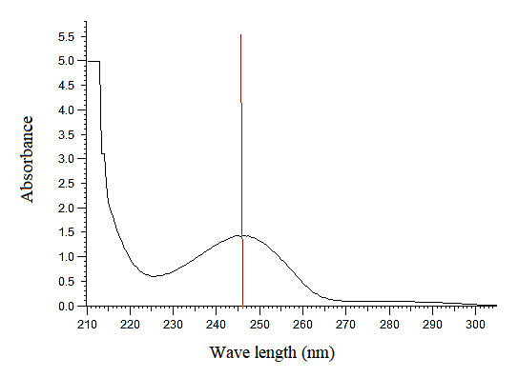

**Figure 3: UV-Vis spectrum of Linuron showing its maximum absorption wavelength**

**Figure 4: Linuron calibration curve by UV-Vis.**

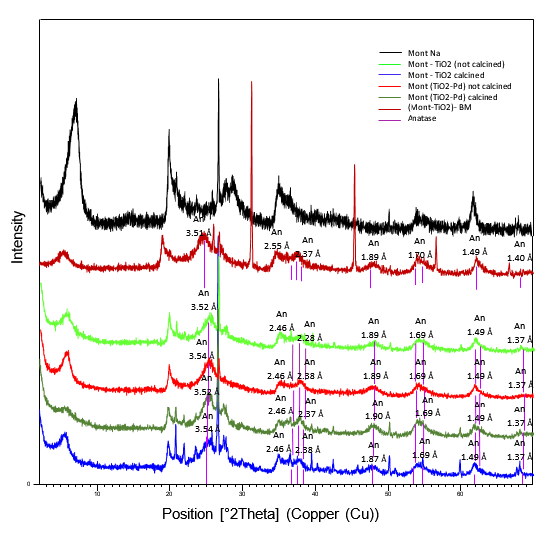

**Figure 5: XRD patterns of Mont-Na and the modified montmorillonite**

As for the pristine sodic material, the characteristic peak corresponding to the (001) reflection of 2:1 phyllosilicate clays is observed for the TiO2 pillared one undoped before and after calcination and the TiO2 pillared and palladium doped one before calcination which indicate that the laminar structure of the clay is preserved even after modification for the calcined TiO2 pillared clay. For the purified clay, the peak at 2ϴ = 6.8° corresponds to a basal distance d001 of 13 Å in agreement with what is well established for sodic montmorillonite5,45. This result indicates the presence of a single water layer in the interlayer space of montmorillonite6,48.

The diffraction pattern of titanium pillared clay (Mont-TiO2) non calcined shows a diffraction line d001 at 2ϴ = 5.8° indicating the formation of titanium pillars as corresponding to an increase of the basal distance to 16 Å. After calcination, the sample exhibits a slight decrease of the d001 (15Å) as compared to the non-calcined sample. This shift is likely due to a dehydration undergone by the pillars during the calcination step. Still the basal distance for the material after calcination is larger than for the pristine material revealing that the expansion of the clay interlayer distance during the pillaring process is thermally stable.

A diffraction peak corresponding to the (101) reticular plane of the anatase form of TiO2 was detected at 25.5°25. A bulk anatase phase TiO2 generates other peaks at 2ϴ angles of 37.9, 47.9, 53.8, 62.7 and 68.8°. For our samples, these peaks are really faint and for most of them cannot be distinguished from the clay pattern. This suggests that the presence of bulk anatase crystallites having grown independently of the clay is unlikely and that the pillars successfully intercalated into the clay are made of anatase TiO2 developed as column built along the (101) direction25,49-51.

The XRD pattern of the palladium doped pillared clay (Mont-(TiO2-Pd) almost coincides with that of TiO2 pillared clay. In particular, no diffraction peak due to any palladium containing phase was observed suggesting that no independent Pd-containing bulk phase was formed and that Pd ions are uniformly incorporated and dispersed into the lattice of the TiO2 pillars46,52,53. Moreover, the d001 distance of Mont-(TiO2-Pd) was 15 Å before calcination, but after the calcination, we observe a collapse of this peak. This is probably due to the migration of some ions palladium (Pd2+) into the octahedral sheets of the clay.

For the methylene blue sensitized sample, the d001 distance was 14 Å, namely more than the pristine material but less than the pillared samples. The (101) peak of anatase is still there, but less intense. This suggests that the incorporation of BM is somehow detrimental for the pillars, not affecting their structure but likely shortening them. The reason for this is unknown at this stage, but the fact that the pillars are affected by BM is an indication that BM indeed interacts with the pillars and penetrates in the interlayer space of the clay.

**FT-IR analysis**: The structural evolution of the aluminosilicate was characterized by FT-IR spectroscopy. The IR spectra of the sodic montmorillonite (Na-Mont) and the three modified systems are given in figure 6.

The FT-IR spectra of Mont–Na, Mont-TiO2, Mont-(TiO2-Pd) and (Mont-TiO2)-BM showed bands at 3631, 3627, 3625 and 3623 cm-1 respectively corresponding to the stretching vibration of the hydroxyl group Al-OH and Si-OH species and the interlayer water molecules45,54. The introduction of titanium in the sodic montmorillonite by the pillaring process led to broader bands due to the presence of additional new types of –OH groups brought by the pillars. The absorption band observed for the Mont-Na got weakened and shifted to lower wave number (3627 cm-1) for the Mont-TiO2 sample; this fact indicated that the overall H2O content is reduced by dehydroxylation and the replacement of the hydrated pristine cation by TiO2 pillars.

Besides, the OH bending peak corresponding to the bound water is detected between 1600 and 1652cm-1 for the prepared materials and the one at around 1030 cm-1 is attributed to the asymmetric stretching vibration of SiO2 in tetrahedral form25,55. The band in the range of 500 and 1000 cm-1 corresponds to the Ti–O stretching vibration of TiO2 phase suggesting the existence of both Ti–O–Ti and Ti–O–Si bonds in the modified montmorillonite49,56-58 further suggesting that anatase clusters are strongly bonded to the silicate through a chemical bond30.

A new strong band at 3000 cm−1 can be observed in (Mont-TiO2)-BM sample corresponding to symmetric and asymmetric stretchings of CH2 in the dye structure. Additionally, this sample exhibits a peak at 1396 cm-1 related to the stretching vibration of C-C59. This fact shows that methylene blue was indeed introduced at the surface or in the interlayer space of the montmorillonite**.**

**SEM images:** The SEM photographs of the prepared samples (Mont-Na, Mont-TiO2, Mont-(TiO2-Pd) and (Mont-TiO2)-BM) are given in figure 7. The Mont-Na micrograph shows large particle aggregates**.** This microstructure of the clay was retained in the Mont-TiO2 after microwave calcination; the same observations have been made by other authors researchers45,46. After doping with palladium into TiO2 and add this mixture to the montmorillonite, the morphology changed remarkably. The SEM image of Mont-(TiO2-Pd) shows even larger particle aggregates with smoother surfaces. Beside this difference, the SEM pictures show that doping the pillared clay with transition metal does not affect its external structure. A similar observation was made for the photosensitized pillared clay (Mont-TiO2)-BM showing larger platelets.

**Nitrogen adsorption/desorption isotherms**: Figure 8 shows adsorption/desorption isotherms of nitrogen for the pristine sodic and modified montmorillonite (Mont-Na, Mont-TiO2 and Mont-(TiO2-Pd)).

Besides the uptake at very low pressure, the adsorption isotherm of sodic clay (Mont-Na) is rather of type III in the Brunauer, Deming, Deming and Teller (BDDT) classification60. In particular it does not show sudden increase in the nitrogen uptake at intermediate pressure which is characteristic of samples not undergoing a capillary condensation. Such absence of condensation is typical of non-mesoporous samples, but it is also typical for slit-shaped porous samples. The occurrence of a capillary decondensation along the desorption isotherm confirms this latter hypothesis and it is thus totally in line with the fact that montmorillonites are layered materials.

The hysteresis loop formed by the isotherms is clearly of type H3 in the International Union of Pure and Applied Chemists (IUPAC) classification attributed to slit-shaped pores in layered materials2,61-64. One should note that the significant nitrogen uptake at very low partial pressure might correspond a small population of micropores likely present inside the clay sheets.

**Figure 6: FT-IR spectra of the pristine and modified montmorillonite**

**Mont-Na**

**Mont-TiO2**

**Mont-(TiO2-Pd)**

**(Mont-TiO2)-BM**

**Fig. 7: SEM micrographs of the prepared photocatalysts**

**Figure 8: Nitrogen adsorption/desorption isotherms of the prepared materials**

The adsorption isotherms of the Mont-TiO2 and Mont-(TiO2-Pd) samples present higher nitrogen uptake at low pressure, meaning the presence of more micropores. Besides, the adsorption isotherms are more of type II than the pristine clay, but still do not present an obvious capillary condensation. The desorption isotherms present a capillary decondensation; the combination of type II at the adsorption and type IV at the desorption is in line with slit-shaped pores and reflects that the pillaring process has not affected the textural morphology of the layered material.

Still, the higher amplitude of the hysteresis for the pillared undoped and Pd-doped materials indicates the volume of pores in these two samples which is bigger than in the pristine one. This is consistent with the expected effect of the pillaring process, increasing the space between the stacked sheets.

Table 2 presents the values of BET specific surface area and total volume of pores extracted from nitrogen adsorption/desorption isotherms. The incorporation of TiO2 pillars between the clay layers considerably increases the surface area; the BET surface area of pillared montmorillonite sample (Mont-TiO2) is indeed much bigger (224 m2/g) than that of the pristine montmorillonite (63 m2/g), suggesting that the pillaring process leads to a dramatic increase in porosity of layer clays.

After doping with palladium, the BET specific surface area of the calcined photocatalyst is further higher (242 m2/g) than that of the calcined support (Mont-TiO2). It is suggested that a better distribution of pillars in the interlayer spaces may be responsible for the improved textural properties of Mont-(TiO2-Pd).

The growth of Pd particles seems to create new pores in the TiO2 network through destruction of parts of the channel walls. Such creation of new pores is well-known, for example, from the growth of Pt particles in zeolites65. Overall, the total pore volume increases from 0.082 cm3/g for the purified clay to 0.18 cm3/g for the pillared clay samples.

**Table 2**

**Textural properties of the prepared materials**

|  |  |  |
| --- | --- | --- |
| **Sample** | **Surface area (m2/g)** | **Total pores volume(cm3/g)** |
| Mont-Na | 62 | 0.082 |
| Mont-TiO2 | 224 | 0.188 |
| Mont-(TiO2-Pd) | 241 | 0.186 |

**Elemental analysis**: The chemical composition of the prepared materials was determined by µXRF (X-ray fluorescence microanalysis), focusing on the metal contents. The results are shown in table 3 and figure 9. For Mont-TiO2, the presence of an intense peak around 4.50 keV is assigned to titanium. The amount of titanium increases with a corresponding decrease in the amount of exchangeable cations detectable in XRF. This points to the replacement of interlamellar cations with stable titanium oxide pillars. Na being the most abundant cation in the pristine clay is not detectable by XRF and the evolution of its concentration can thus not be compared before and after the pillaring process. For Mont-(TiO2-Pd), the peak of Pd is not distinct at 3 keV likely because of the low nominal content of Pd (0.5%w/w) which is incorporated into the TiO2 pillars.

**Thermal analysis (DTA/TGA):** Thermal analysis was performed in order to check the influence of applied modifications on the thermal stability of the pillared, doped and sensitized clays. Coupled diagrams of differential thermal analysis (DTA) and thermogravimetric analysis (TG) of the pristine montmorillonite (Mont-Na), TiO2 pillared montmorillonite (Mont- TiO2), palladium-doped pillared montmorillonite (Mont–(TiO2-Pd)) and methylene blue photosensitized pillared montmorillonite (Mont-TiO2)-BM are presented in figure10.

TG-DTA profiles (Figure 10) show that the pillared systems are thermally stable until 500°C. Thermograms of all the samples show an initial endothermic peak within 25 to 130°C corresponding to the loss of physisorbed water, this event being accompanied by a mass loss of about 10%, 14%, 13%, 10% for Mont-Na, Mont-TiO2, Mont-(TiO2-Pd) and (Mont–TiO2)–BM respectively. The weight loss above 200°C in sodium montmorillonite results from the removal of water initially present between the layers and to dehydroxylation of the layers. This collapse slowly continued up to 800°C.

The gradual weight loss to about 500°C observed for the pillared clays (Mont-TiO2, Mont–(TiO2-Pd) and (Mont–TiO2)–BM) is attributed to the dehydroxylation of OH groups associated with the interlayer polycations due to the pillaring process22,66. The only exothermic peak observed at 632°C for the sample (Mont-TiO2)-BM is probably due to the combustion of methylene blue fixed on the pillars and on the sheets clay.

**Photocatalytic activity**: To examine the photocatalytic activity of the prepared photocatalysts (Mont-TiO2, Mont–(TiO2-Pd) and (Mont–TiO2)–BM), the photodegradation of Linuron was used as a probe photoreaction. Figure 11 illustrates the decrease in the concentration of Linuron with reaction time photocatalyzed in the presence of Mont-TiO2, Mont–(TiO2-Pd) and (Mont–TiO2)–BM under UV light irradiation.

Prior to the evaluation of the photocatalytic activity of the prepared catalysts, the degradation of the phenylurea herbicide (Linuron) in the absence of catalyst under UV illumination was tested. The herbicide degraded very slowly compared with the reaction rates obtained using photocatalysts. The comparison between the different photodegradation curves of the Linuron (Figure 11) shows that the rate of the degradation depends on the quality of the photocatalyst used.

**Table 3**

**XRF microanalysis results\***

|  |  |  |  |  |  |
| --- | --- | --- | --- | --- | --- |
|  | **13Al(%wt)** | **14Si(%wt)** | **19K(%wt)** | **22Ti(%wt)** | **26Fe(%wt)** |
| Mont-Na | 15 | 74 | 3 | 0 | 7 |
| Mont-TiO2 | 10 | 43 | 1 | 40 | 5 |
| Mont-(TiO2-Pd) | 8 | 37 | 2 | 51 | 3 |
| (Mont-TiO2)-BM | 11 | 46 | 1 | 37 | 5 |

* Ca and Na were not detectable with the XRF machine we used; this means that Si, Al and Fe contents are overestimated for Mont-Na. Thus, when Ti is introduced, the Si, Al and Fe contents decrease should not be interpreted as due to a disappearance of them. Indeed, Ti has taken the place of Ca and Na (and also of K, which underwent a real decrease of content along the pillarization) and is detectable, so inducing the apparent decreasing contents of Si, Al and Fe. Si, Al and Fe are likely in unmodified absolutely contents as in Mont-Na, but actually as Ti which is detectable by XRD replaced Ca and Na which are not detectable, Si, Al and Fe undergo a decrease of the fraction of the detectable elements in the samples

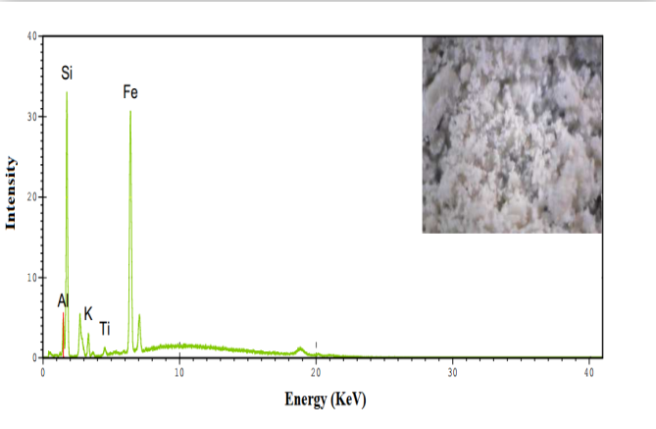 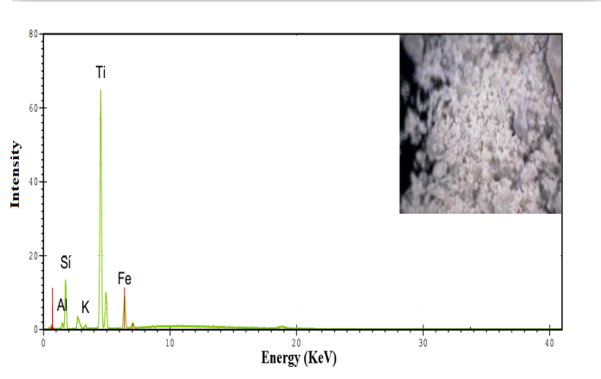

Mont-TiO2

Mont-Na

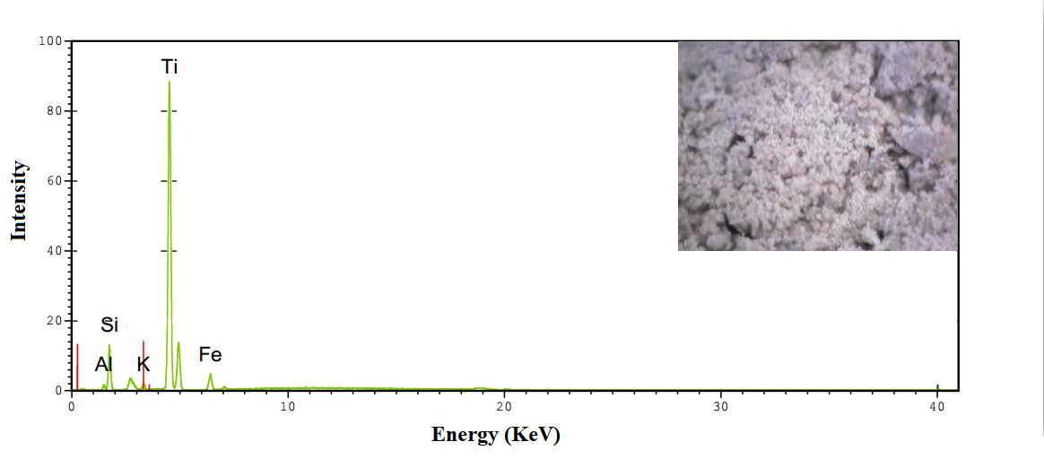 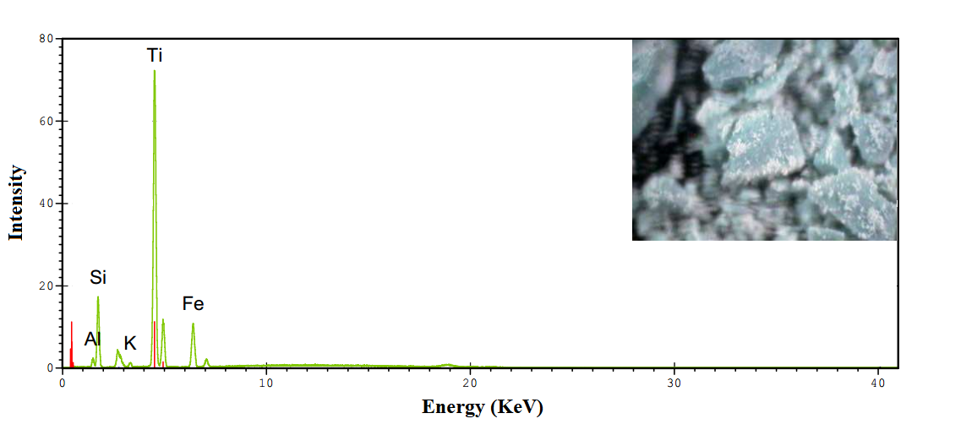

Mont-(TiO2-BM)

Mont-(TiO2-Pd)

**Figure 9: XRF microanalysis of the purified and modified montmorillonite**

For (Mont-TiO2)-BM the radiation excites an electron from the dye and then it is injected to the conduction band of the semiconductor oxide; the photosensitization process by MB can be described in the case of a semiconductor oxide (TiO2) as follows67,68:

TiO2 +hѵ(λ<382 nm) 🡪h+(VB) + e-(CB) (1)

e– + O2 🡪 O2 **.–** (2)

h+(VB) + OH- 🡪 •OH (3)

MB(ads) + hѵ 🡪 MB* (ads) (4)

MB* (ads) + TiO2 🡪 MB(ads) + h+(VB) + e-(CB) (5)

MB*(ads) + O2 🡪MB(ads) + O2**.-** (6)

LIN + O2•-  🡪 Photoproducts (7)

TiO2(e-CB) + O2•- + H+ 🡪 HO2- + TiO2 (8)

HO2- + H+ 🡪 H2O2 (9)

H2O2 + e- 🡪 •OH + OH-  (10)

LIN + •OH 🡪 Photoproducts (11)

Here, the photocatalyst (Mont-TiO2)-BM has a low degradation rate whereas the use of the Mont-TiO2 matrix increases the photocatalytic activity. This phenomenon can be explained by the fact that photosensitization by methylene blue would not have influenced the band gap of the TiO2 semiconductor supported on the clay, this is probably due to the too low concentration of the dye (10-3M).

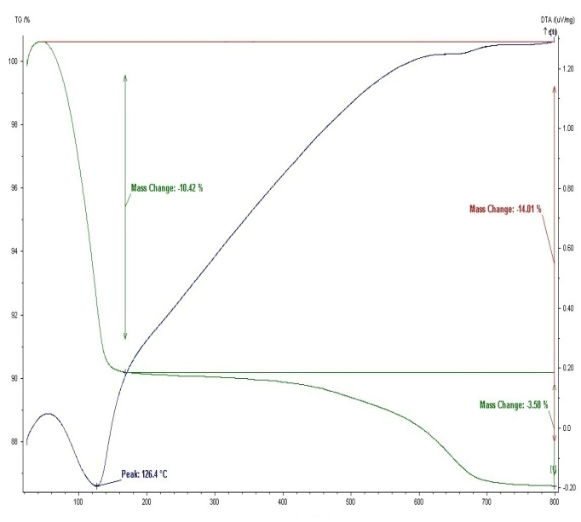 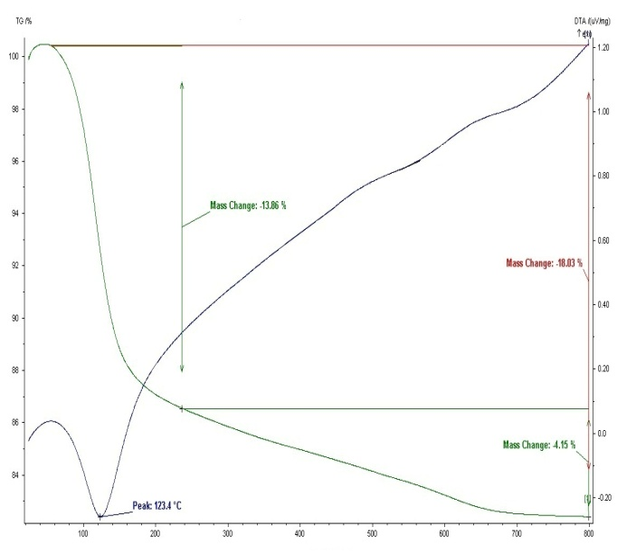

Mont-TiO2

Mont-Na

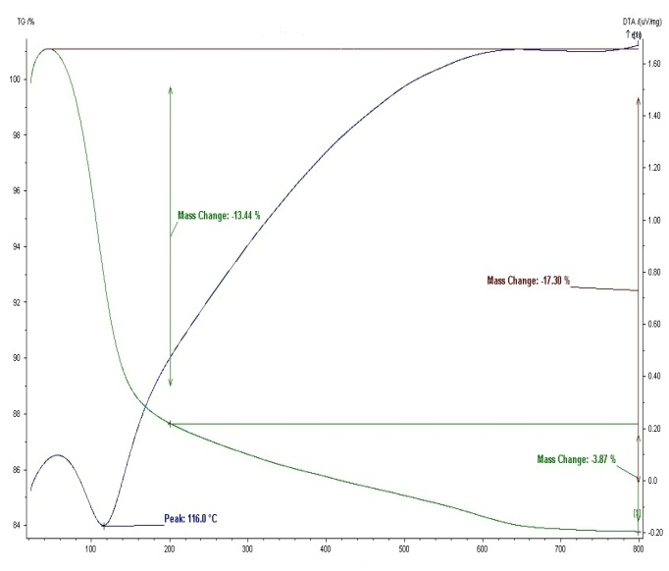 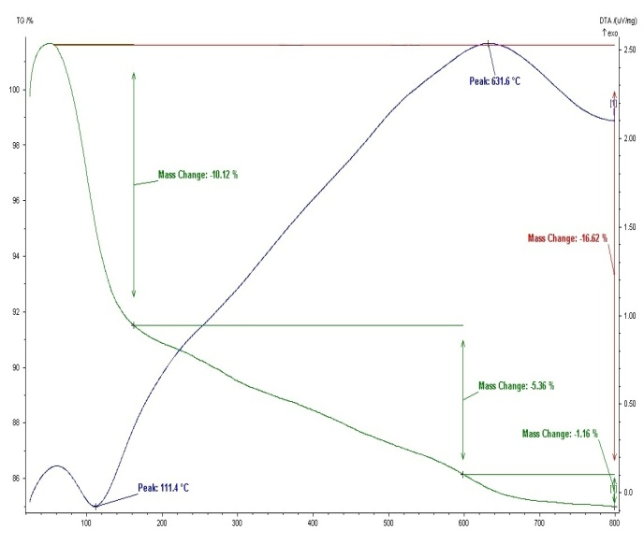

Mont-(TiO2-BM)

Mont-(TiO2-Pd)

**Figure 10: TGA/DTA diagram of the purified and modified montmorillonite**

**Figure 11: Photocatalytic performance of Mont-TiO2, Mont-(TiO2-Pd) and (Mont –TiO2)-BM)**

**under UV light irradiation**

During heterogeneous photocatalysis, an electron is transferred from the valence band to the conducting band of the semiconductors in Mont-TiO2, after which the electron may react with O2 on the surface of the semiconductor particles to yield $O_{2}^{.-}$. Alternatively, if an organic compound is adsorbed on the surface of the photocatalyst, one-electron reduction process may also take place.

Most transition metals have multiple potential oxidation states. Relying on this property, transition metals can greatly reduce the electron and hole recombination by efficiently serving as charge carrier trapping centers. In general, compared to alkali or alkaline earth metals, the atomic radii of transition metals are similar to that of TiO2, making them more technically accessible into the crystal lattice of TiO269. It is clearly seen that Mont-TiO2 exhibited a slight enhancement in photocatalytic activity compared to the Pd doped TiO2 pillared clay (Fig. 11). Therefore, it was probably attributed to the fact that in the presence of Pd, only a few electrons can be excited from the VB to the CB of TiO2 which leads to a low degradation efficiency.

Therefore, to increase the photocatalytic activity of TiO2 doped with metal ions, it is necessary to widen the range of absorption towards the visible light. It has been shown that doping by different transition metals allows a shift of the absorption band of theTiO2 towards the visible field70. The degradation mechanism by electron transfer is explained in fig. 12, when Mont-(TiO2-Pd) is exposed to UV light, the electrons excited below the Fermi level of the Pd in the VB are transferred into the CB leaving behind positive charges (h+) in the VB.

As the CB of TiO2 is an electron acceptor, it readily accepts the electrons that are transferred from the Pd to form superoxide anion radicals (•O2−). This is followed by protonation that yields •HO2 radicals. These instable •HO2 radicals further form H2O2 and lead to the formation of hydroxyl radicals (•OH), an active species that is responsible for the degradation of LIN.

**Figure 12: Schematic diagram of electron transfer in degradation of LIN**

The •OH radical generation takes place through the oxidation of surface bound. OH**-** ions or water molecules adsorbed on the material, being the primary step eventually leading to the total mineralization of the pollutants, so it is concluded that **•**OH radicals made major contributions for the photocatalytic degradation of LIN while h+ has only a minor contribution71.

**Conclusion**

The aim of this work was the preparation and physical-chemical characterization of a specific type of modified clay materials, namely TiO2 pillared montmorillonite, Pd doped TiO2 pillared montmorillonite and methylene blue photosensitized TiO2 pillared montmorillonite. TiO2-pillared montmorillonite has been successfully synthesized by using microwave calcination for 15 min. The expansion of the interlayer space of the clay upon pillaring and its subsequent retention in the modified pillaring clay is elucidated from XRD study, the results reveal that the pillared clay sample has well ordered layers with insertion of titania pillars which caused an increase of the basal spacing in the clay.

The intercalation process was also confirmed by the results of FTIR. The IR study indicated the structural integrity of the clay lattice in the pillared and the modified pillared systems. The materials obtained after pillaring showed micro and mesoporosities and are thermally stable, have high surface areas with large internal pore systems open to penetration by gaseous or liquid reagents. The specific surface areas of all the prepared materials exceed 230m2/g. Also TGA /DTG thermograms showed that the modification of montmorillonite by doping or photosensitization increases their thermal stability. The transition metal ions introduced by the described method are located into the pillars.

The effect of the dopant (palladium) and the photosensitizer (methylene blue) on the photocatalytic efficiency was investigated by performing the photodegradation of Linuron under radiation of UV light. Results showed that the efficiency of photocatalyst varied in the following order: Mont-TiO2› Mont–(TiO2-Pd) › (Mont–TiO2)–BM). We understood that to improve the photocatalytic activity of TiO2-pillared clay by the addition of transition metal, we have to work in the visible field.

**Acknowledgement**

K. Guelil, A. Sayfi and Meki are acknowledged for DRX, MEB and MicroFX experiments respectively.

**Réferences**

1.Occeli M.L., Catalytic Cracking with an Interlayered Clay. A Two-Dimensional Molecular Sieve, *Ind. Eng. Chem. Prod. Res. Dev*., **22**, 553 **(1983)**

2.Yamanaka S., Nishihara T. and Hattori M., Preparation and properties of titania pillared clay, *Mat. Chem. and Phys*., **17**, 87 **(1987)**

3.Occelli M.L. and Rennard R.J., catalysts containing pillared clays, *Catal. Tod*., **2**, 309 **(1988)**

4.Lahodny-Sarc O. and Khalaf H., Some considerations of the influence of source clay material and synthesis conditions on the properties of Al-pillared clays, *Appl. Clay Sci.*, **8**, 405 **(1994)**

5. Khalaf H., Bouras O. and Perrichon V., Synthesis and characterization of Al-pillared and cationic surfactant modified Al-pillared Algerian bentonite, *Microp. Mater.*, **8**, 141 **(1997)**

6.Brindley G.W. and Sempels R.E., Preparation and properties of some hydroxyl-Alluminium Beidellites, *Clay Min.*, **12**, 229 **(1977)**

7. Barrer R.M. and Macleod D.M., Intercalation and sorption by montmorillonite, *Trans. Faraday Soc.*, **50**, 980 **(1954)**

8. Barrer R.M. and Macleod D.M., Activation of montmorillonite by ion exchange and sorption complexes of tetra-alkyl ammonium montmorillonites, *Trans. Faraday Soc*., **51**, 1290 **(1955)**

9.Manos C.G., Mortland Jr. M.M. and Pinnavaia T.J., Tris(acetylacetonato)silicon(iv) binding to montmorillonite and hydrolysis to interlayer silicic acid, *Clays and Clay Min*., **32(2)**, 93 **(1984)**

10. Barrer R.M., Expanded clay minerals: a Major Class of Molecular sieves, *J. of Inclus. Phenom.*, **4**, 109 **(1986)**

11. Burch R. and Warrurton C.T., Zr-containing pillared interlayer clays, I. Preparation and structural characterization, *J. of Catal.*, **97**, 503 **(1986)**

12.Suzuki K., Horio M., Masuda H. and Mori T., Preparation and property of zirconia- pillared montmorillonite having different pillar populations, *Bull. Chem. Soc. Jpn*., **64(2)**, 732 **(1991)**

13.Bernier A., Admaiai L.F. and Grange P., Synthesis and characterization of titanium pillared clays. Influence of the temperature of preparation,*Appl. Catal.*,**77**, 269 **(1991)**

14.Michot L.J. and Pinnavaia T.J., Improved Synthesis of Alumina-Pillared Montmorillonite by Surfactant Modification, *Chem. Mater.*, **4**, 1433 **(1992)**

15.Lin J.T., Jong S.J. and Cheng S., A new method for preparing microporous titanium pillared clays, *Micropor. Mater.*, **1**, 281 **(1993)**

16.Del Castillo H.L., Gil A. and Grange P., Preparation and characterization of sulfated titanium-modified pillared montmorillonite, *Catal. Lett*., **43**, 133 **(1997)**

17.Cool P. and Vansant E.F., Pillared Clays: Preparation, Characterization and Applications, In Synthesis, Molecular Sieves, *Sci. and Techn*., **1**, 265 **(1998)**

18.Valverde J.L., Canizares P., Sun Kou M.R. and Molina C.B., Of Al-pillared Enhanced thermal stability of Al-pillred smectites modified with Ce and La, *Clays and Clay Min.*,**48(4)**, 424 **(2000)**

19.Houari M., Saidi M., Tabet D., Pichat P. and Khalaf H., The Removal of 4-chlorophenol and Dichloroacetic Acid in Water UsingTi-, Zr- and Ti/Zr-Pillared Bentonites as Photocatalyst, *Am. J. of Appl. Sci*., **2(7)**, 1136 **(2005)**

20.Pichat P., Khalaf H., Tabet D., Houari M. and Saidi M., Ti-montmorillonite as photocatalyst to remove 4-chlorophenol in water and methanol in air, *Environ. Chem. Lett.*, **2**, 191 **(2005)**

21.Bouras O., Bollinger J.C., Baudu M. and Khalaf H., Adsorption of diuron and its degradation products from aqueous solution by surfactant-modified pillared clays, *Appl. Clay Sci.*, **37**, 240 **(2007)**

22.Barama S., Dupeyrat-Batiot C., Capron M., Bordes-Richard E. and Bakhti-Mohammedi O., Catalytic properties of Rh, Ni, Pd and Ce supported on Al-pillared montmorillonites in dry reforming of methane, *Catal. Tod.*, **141**, 385 **(2009)**

23.Damardji B., Khalaf H., Duclaux L. and David B., Preparation of TiO2-pillared montmorillonite as photocatalyst Part I. Microwave calcination, characterisation and adsorption of a textile azo dye, *Appl. Clay Sci.*, **44**, 201 **(2009)**

24.Tabet D., Robert D., Pichat P. and Khalaf H., Ti/Cr-pillared clay as photocatalysts for 4-chlorophenol removal in water,*Desa. and Water Treat*, **13**, 437 **(2010)**

25.Chen D., Zhu Q., Zhou F., Deng X. and Li F., Synthesis and photocatalytic performances of the TiO2 pillared montmorillonite, *J. of Hazard Mater.*, **235–236**, 186-93 **(2012)**

26.Khalfaoui-Boutoumi N., Boutoumi H., Khalaf H. and David B., Synthesis and characterization of TiO2–Montmorillonite/ Polythiophene-SDS nanocomposites: Application in the sonophotocatalytic degradation of rhodamine 6G, *Appl. Clay Sci.* **80–81**, 56 **(2013)**

27.Abdennouri M., Baalala M., Galadi A., El Makhfouk M., Bensitel M., Nohair K., Sadiq M., Boussaoud A. and Barka N., Photocatalytic degradation of pesticides by titanium dioxide and titanium pillared purified clays, *Arab. J. of Chem*., **9**, S313 **(2016)**

28.Pode R., Popovici E., Vasile A., Cocheci L. and Dvininov E., Sorption and photocatalytic degradation of azoic dyeson TiO2-pillared montmorillonitic clay, *Revue Roumaine de Chimie*, **54(4)**, 313 **(2009)**

29.Dvininov E., Popovici E., Pode R., Cocheci L., Barvinschi P. and NicaV., Synthesis and characterization of TiO2-pillared Romanian clay and theirapplication for azoic dyes photodegradation, *J. of Hazard Mater*., **167**, 1050 **(2009)**

30.Yang S., Liang G., Gu A. and Mao H., Synthesis of TiO2 pillared montmorillonite with ordered interlayermesoporous structure and high photocatalytic activity by anintra-gallery templating method, *Mater. Res. Bull.*, **48**, 3948 **(2013)**

31.Zuo S., Ding M., Tong J., Feng L. and Qi C., Study on the preparation and characterization of a titanium-pillared clay-supported CrCe catalyst and its application to the degradation of a low concentration of chlorobenzene, *Appl. Clay Sci.*, **105–106**, 118 **(2015)**

32. Hoffmann M.R., Martin S.T., Choi W. and Bahnemann D.W.,Environmental Applications of Semiconductor Photocatalysis,*Chem. Rev.*, **95**, 69 **(1995)**

33.Fujishimaa A., Zhanga X. and Tryk D.A., Heterogeneous photocatalysis: From water photolysis to applications in environmental cleanup, *Internat. J. of Hydrog. Energy*, **32**, 2664 **(2007)**

34.Lathasree S., Manoharan N., Kavitha V., Anand Babu C. and Sharma B.K., A review of heterogeneous semiconductor photocatalysis of organic contaminants, *Internat. J. on Appl. Bioengin.*, **2(1)**, 57 **(2008)**

35.Zhang Y., Payne D.T., Pang C.L., Fielding H.H. and Thornton  [G., Non-Band-Gap Photoexcitation of Hydroxylated TiO](http://pubs.acs.org/doi/abs/10.1021/acs.jpclett.5b01508)[2](http://pubs.acs.org/doi/abs/10.1021/acs.jpclett.5b01508)[,](http://pubs.acs.org/doi/abs/10.1021/acs.jpclett.5b01508) *[J. Phys. Chem. Lett](http://pubs.acs.org/doi/abs/10.1021/acs.jpclett.5b01508)*[.,](http://pubs.acs.org/doi/abs/10.1021/acs.jpclett.5b01508) **[6(17)](http://pubs.acs.org/doi/abs/10.1021/acs.jpclett.5b01508)**[, 3391](http://pubs.acs.org/doi/abs/10.1021/acs.jpclett.5b01508) **[(2015)](http://pubs.acs.org/doi/abs/10.1021/acs.jpclett.5b01508)**

36.Yan H., Wang X., Yaon M. and Yao X., Band structure design of semiconductors for enhanced photocatalytic activity: The case of TiO2, *Chin. Mater. Res. Soc.: Mater. Internat.*, **23(4)**, 402 **(2013)**

37.  [Serpone](http://pubs.acs.org/author/Serpone%2C+N) N. and  [Emeline](http://pubs.acs.org/author/Emeline%2C+A+V) A.V., Semiconductor Photocatalysis - Past, Present and Future Outlook, *J. Phys. Chem. Lett.*, **3(5)**, 673 **(2012)**

38.Dong H., Zeng G., Tan L., Fan C., Zhang C., He X. and He Y., An overview on limitations of TiO2-based particles for photocatalytic degradation of organic pollutants and the corresponding countermeasures, *Wat. Res.*, **79**, 128 **(2015)**

39.Damardji B., Khalaf H., Duclaux L. and David B., Preparation of TiO2-pillared montmorillonite as photocatalyst Part II:Photocatalytic degradation of a textile azo dye, *Appl. Clay Sci*., **45**, 98 **(2009)**

40. [Chen](https://www.sciencedirect.com/science/article/pii/S0021979713006905?via%3Dihub#!) D., [Du](https://www.sciencedirect.com/science/article/pii/S0021979713006905?via%3Dihub#!) G., [Zhu](https://www.sciencedirect.com/science/article/pii/S0021979713006905?via%3Dihub#!) Q. and [Zhou](https://www.sciencedirect.com/science/article/pii/S0021979713006905?via%3Dihub#!) F., Synthesis and characterization of TiO2 pillared montmorillonites: Application for methylene blue degradation, [*J. of Coll. and Interf. Sci*](https://www.sciencedirect.com/science/journal/00219797)*.*, [**409(1)**,](https://www.sciencedirect.com/science/journal/00219797/409/supp/C) 151 **(2013)**

41.SzczepanikB., Photocatalytic degradation of organic contaminants over clay-TiO2 nanocomposites: A -review, *Appl. Clay Sci.*, **141**, 227 **(2017)**

# 42. Candal R. and Martınez-de la Cruz A., Chapter 2: New Visible-Light Active Semiconductors, Book: Photocatalytic Semiconductors, Synthesis, Characterization and Environmental Applications, Editors: **Hernández-Ramírez**, Aracely, **Medina-Ramirez**, Iliana, Eds., 289 (2015)

43.Litter M.I., Review: Heterogeneous photocatalysis. Transition metal ions in photocatalytic systems, *Appl. Catal. B: Environ.*, **23**, 89 **(1999)**

44. Sterte J., Synthesis and properties of titanium oxide cross linked montmorillonite, *Clays and Clay Min.*,**34(6)**, 658 **(1986)**

45. Del Castillo H.L. and Grange P., Preparation and catalytic activity of titanium pillared montmorillonite, *Appl. Catal. A: General*, **103**, 23 **(1993)**

46. Ding X., An T., Li G., Zhang S., Chen J., Yuan J., Zhao H., Chen H., Sheng G. and Fu J., Preparation and characterization of hydrophobic TiO2 pillared clay: The effect of acid hydrolysis catalyst and doped Pt amount on photocatalytic activity, *J. of Coll. and Interf. Sci.*, **320**, 501 **(2008)**

47.Kohno Y., Kinoshita R., Yoda K., Shibata M., Matsushuma R., Tomita Y., Maeda Y. and Kobayashi K., stabilization of naturel anthocyanin by intercalation into montmorillonite, *Appl. Clay Sci.*, **42**, 519 **(2009)**

48.Liu J. and Zhang G., Recent advances in synthesis and applications of clay-based photocatalysts: a review, *Phys. Chem. Chem. Phys*., **16**, 8178 **(2014)**

49.Fatimah I., Composite of TiO2 –montmorillonite from Indonesia and its photocatalytic properties in methylene blue and E. coli reduction, *Mater. Environ. Sci.*, **3(5)**, 983 **(2012)**

50.Schoonheydt R.A., Pinnavaia T., Lagaly G. and Gangas N., Pillared clays and pillared layered solids (technical report), *Pur. Appl. Chem.*, **71(12)**, 2367 **(1999)**

51.Ooka C., Yoshida H., Horio M., Suzuki K. and Hattori T., Adsorptive and photocatalytic performance of TiO2 pillared montmorillonite in degradation of endocrine disruptors having different hydrophobicity, *Appl. Catal. B: Environ.*, **41**, 313 **(2003)**

52.Behnajady M.A., Modirshahla N., Shokri M. and Rad B., Enhancement of photocatalytic activity of TiO2 nanoparticles by silver doping: photodeposition versus liquid impregnation methods, *Global NEST J*., **10(1)**, 1 **(2008)**

53.Abd El-Rady A., Abd El-Sadek M.S., El-Sayed Breky M.M. and Assaf F.H., Characterization and Photocatalytic Efficiency of Palladium Doped-TiO2 Nanoparticles, *Adv. in Nanop.*, **2**, 372 **(2013)**

54. El Miz M., Salhi S., Chraibi I., El Bachiri A., Fauconnier M.L. and Tahani A., Characterization and Adsorption Study of Thymol on Pillared Bentonite, *Open J. of Phys. Chem.*, **4**, 98 **(2014)**

55.Xu X., Pan Y., Cui X. and Suo Z., Catalytic Combustion of Methane over Ti-Pillared Clay Supported Copper Catalysts,*J. of Nat. Gas Chem.*, **13**, 204 **(2004)**

56.Butman M.F., Ovchinnikov L.N., Karasev N.S., Kochkina N.E., Agafonov A.V. and Vinogradov A.V.,Photocatalytic and adsorption properties of TiO2-pillared montmorillonite obtained by hydrothermally activated intercalation of titanium polyhydroxo complexes, *Beilstein J. Nanotech*., **9**, 364 **(2018)**

57.Yang S., Liang G., Gu A. and Mao H., Synthesis of TiO2 pillared montmorillonite with ordered interlayermesoporous structure and high photocatalytic activity by anintra-gallery templating method, *Mater. Res. Bull*., **48**, 3948 **(2013)**

58.Zhao B., Dang L., Zhang X., Yang N. and Sun Y.,Preparation of TiO2-pillared montmorillonite as photocatalyst andphotocatalytic degradation of methyl orange, *Appl. Mechan. and Mater.*, **190-191**, 534 **(2012)**

59.Chen Q., Kerk W.T., Soutar A.M. and ZengX.T., Application of dye intercalated bentonite for developing latent fingerprints, *Appl. Clay Sci.*, **44**, 156 **(2009)**

60.Sing K.S.W. and Everett D.H., Reporting physisorption data for gas/solid systems with special reference to the determination of surface area and porosity, *Pure and App. Chem*., **57(4)**, 603 **(1985)**

61.Shimizu K.I., Kaneko T., Fujishima T., Kodama T., Yoshida H. and Kitayama Y., Applied Selective oxidation of liquid hydrocarbons over photoirradiated TiO2 pillared clays, *Catal. A: General*, **225**, 185 **(2002)**

62.Ooka C., Yoshida H., Suzuki K. and Hattori T., Highly hydrophobic TiO2 pillared clay for photocatalytic degradation of organic compounds in water, *Micropor. and Mesopor. Mater*., **67**, 143 **(2004)**

63. Liang X., Qi F., Liu P., Wei G., Su X., Ma L., He H., Lin X., Xi Y., Zhu J. and Zhu R., Performance of Ti-pillared montmorillonite supported Fe catalysts for toluene oxidation: The effect of Fe on catalytic activity, *Appl. Clay Sci*., **132-133**, 96 **(2016)**

64. Ferjani W. and Khalfallah Boudali L., Effect of tungsten amount on catalytic behavior of mixed WTi-pillared clay*, J. Mater. Environ. Sci*., **7(3)**, 849 **(2016)**

65. Ismail A.A., Bahnemann D.W., Robben L., Yarovyi V. and Wark M., Palladium Doped Porous Titania Photocatalysts: Impact of Mesoporous Order and Crystallinity, *Chem. Mater.*, **22**, 108 **(2010)**

66.Djellabi R., Ghorab M.F., Cerrato G., Morandi S., Gatto S., Oldani V., Di Michele A. and Bianchi C.L., Photoactive TiO2–montmorillonite composite for degradation of organic dyes in water, *J. Photochem. and Photobiol*. *A: Chemistry*, **295**, 57 **(2014)**

67.Candal R. and ´Nez-de la Cruz A.M., [Photocatalytic Semiconductors: Synthesis, Characterization and Environmental Applications](http://booksdescr.org/ads.php?md5=6b5c1033a928e0840dcf32dd0d150388), Chapter 2: New Visible-Light Active Semiconductors, 41 **(2015)**

68. Kuo W.S., Chiang Y.H. and Lai L.S., Solar photocatalysis of carbaryl rinsate promoted by dye photosensitization, *Dyes and Pigm*., **76**, 82 **(2008)**

69. Taicheng An X.H., Zhang M., Shengand G. and Fu J., Preparation and photocataalytic activities of Fe3+ doped nanometer TiO2 composites, *Res. J. Chem. Environ*., **11(4)**, 13 **(2007)**

70.Legrini O., Oliveros E. and Braun A.M., Photochemical Processes for water treatment, *Chem. Rev.*, **93(2)**, 671 **(1993)**

71.Zeng J., Yang H., Deng J., Liu H., Yi X., Yang L. and Yi B., Common characteristic assessments of transformation mechanism for substituted phenylurea herbicides by reactive oxygen species (ROSs) during photocatalytic process, *Chem. Eng. J.*, **273**, 519 **(2015)**.

(Received, accepted)